Design Document – Personal Finance Manager

1. Project Workflow
This section outlines the step-by-step development workflow for building the application from scratch, as well as the expected execution flow once the project is completed.
Part A: Development Workflow (Implementation Plan)
Phase 1 — Project Setup & Architecture
1. Initialize the Node.js project and install required dependencies (typescript, better-sqlite3, inquirer).
2. Configure tsconfig.json and establish the directory structure (models, repositories, services, cli).
3. Define the core TypeScript interfaces and types in models/.

Phase 2 — Database Foundation
1. Implement DatabaseConnection using the Singleton pattern to ensure a single shared SQLite connection.
2. Build SchemaInitializer to automatically create the expenses, income, and budgets tables upon first execution.

Phase 3 — Data Access Layer (Repositories)
1. Define repository interfaces (e.g., IExpenseRepository) following the Interface Segregation Principle.
2. Create concrete classes that implement these interfaces using parameterised SQL queries.
3. Implement the Strategy pattern for filtering (e.g., CategoryFilterStrategy) to dynamically build SQL WHERE clauses.

Phase 4 — Business Logic Layer (Services)
1. Create validation logic to ensure data integrity before saving to the database.
2. Implement services (ExpenseService, IncomeService, etc.) that orchestrate validation and repository calls. These services will depend on interfaces, applying the Dependency Inversion Principle.
3. Build SummaryService using the Facade pattern to simplify complex cross-repository data aggregation for the CLI.

Phase 5 — Presentation Layer (CLI) & Wiring
1. Develop ConsoleFormatter for standardizing terminal outputs and tables.
2. Build interactive CLI menus using inquirer to capture user actions.
3. Set up src/index.ts as the Composition Root to instantiate all classes, inject dependencies, and launch the application loop.

Part B: Expected Execution Flow
Step 1 — Application Launch
The user will run npm start, executing src/index.ts. This Composition Root will create all repositories, services, and menus, wiring them together via constructor injection.

Step 2 — Database Initialisation
DatabaseConnection.getInstance() will be called. It will verify if a connection exists, create the data/ directory, open finance.db, and trigger SchemaInitializer to ensure tables exist.

Step 3 — Main Menu Loop
MainMenu.run() will display the application banner and enter a continuous navigation loop, prompting the user to select modules (Expenses, Income, Budgets, Summary) via arrow keys.

Step 4 — User Action Execution
When a user selects an action:
1. The CLI menu will collect raw input.
2. The Service layer will validate the input.
3. The Repository layer will execute the SQL statement and return a domain object.
4. The CLI will use ConsoleFormatter to display the formatted results.

Step 5 — Expense Filtering
When filtering expenses, the CLI will create a FilterStrategy object and pass it to ExpenseService.getFilteredExpenses(). The repository will call strategy.toSQLCondition() to get the SQL WHERE clause without needing if/else logic.

Step 6 — Budget Tracking
BudgetService.calculateBudgetStatusForMonth() will fetch budgets and calculate actual spending by calling ExpenseRepository. It will return budget statuses (spent, remaining, percentage) to be rendered by the CLI.

Step 7 — Summary
SummaryService will act as a Facade. The CLI will call a single method, and the service will internally coordinate IncomeRepository and ExpenseRepository to return a complete FinancialSummary object.

Step 8 — Data Persistence
All data will be stored synchronously in data/finance.db using SQLite. Records will survive application restarts automatically without manual saving.

Step 9 — Exit
The user will select Exit from the main menu, terminating the navigation loop and allowing the Node.js process to exit cleanly.

3. SOLID Principles to Apply
Single Responsibility - DatabaseConnection manages the connection only; SchemaInitializer handles schema only; ValidationResult is isolated in its own file; each menu class handles only one module.
Open/Closed - New filter strategies can be added by implementing FilterStrategy — no existing repository or service code needs to change.
Liskov Substitution - Any class implementing IExpenseRepository can replace ExpenseRepository without breaking ExpenseService or SummaryService.
Interface Segregation - IExpenseRepository, IIncomeRepository, and IBudgetRepository are small and focused, no class is forced to implement methods it does not need.
Dependency Inversion - All services depend on repository interfaces, not concrete classes; MainMenu receives injected sub-menus; index.ts is the single composition root.
4. UML Diagrams:
4.1 – Use Case Diagram:
A use case diagram is a simple visual representation that shows how users (actors) interact with a system and what actions (use cases) they can perform.
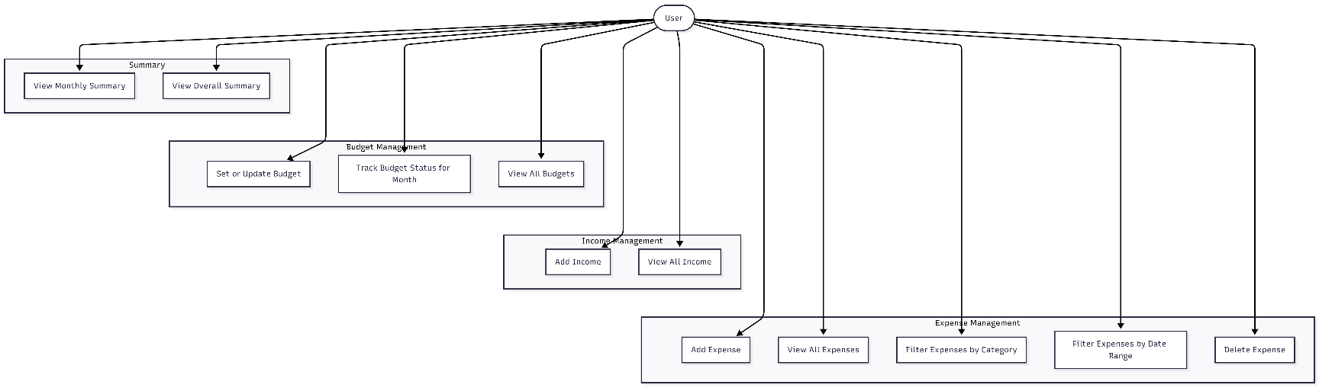

4.2 – System Flow Diagram:
A flow diagram (or flowchart) is a visual representation that shows the step-by-step flow of a process or algorithm, using symbols like arrows and boxes to indicate the sequence of actions.

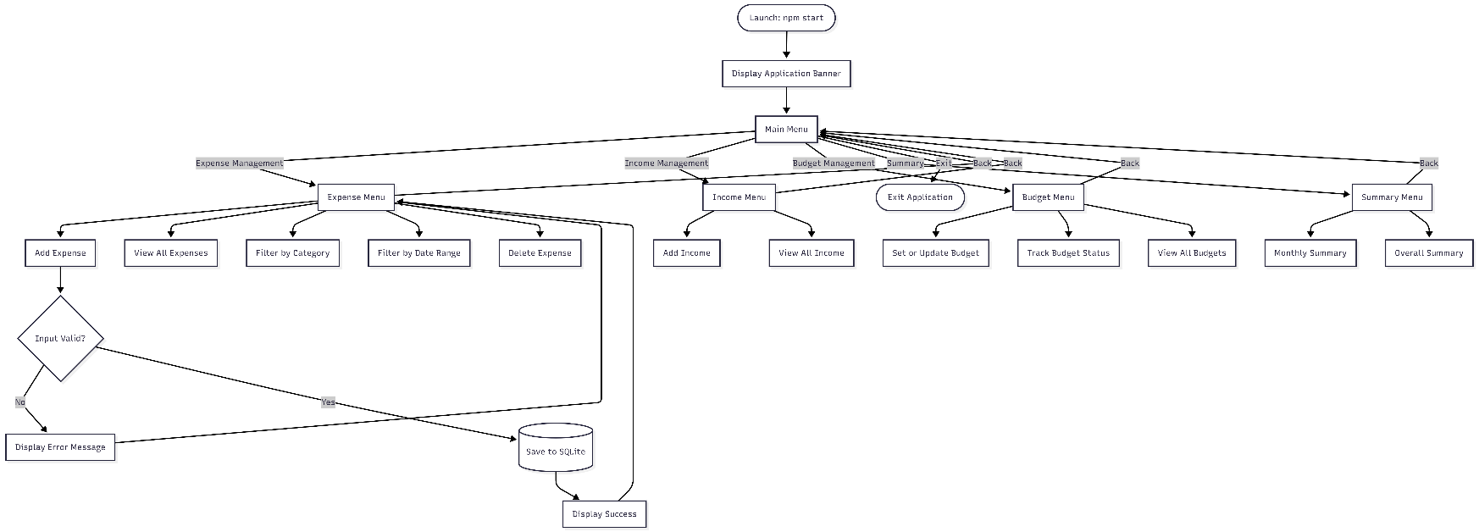

4.3 – Activity Diagram:
An activity diagram is a type of Unified Modeling Language (UML) diagram that shows the flow of activities or actions in a process, including decision points and parallel tasks, from start to finish.
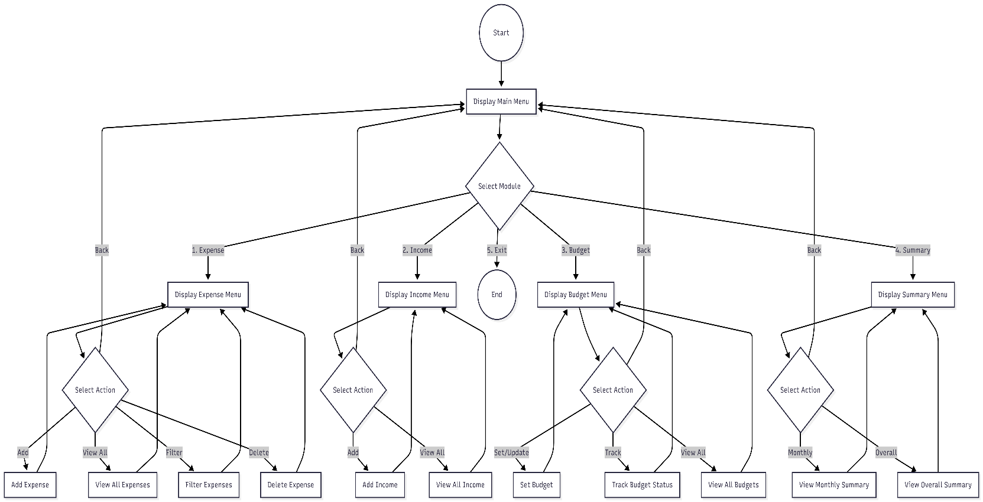

4.4 – Entity Relationship Diagram:
An ER diagram (Entity-Relationship diagram) is a visual representation of a database that shows entities (objects), their attributes (properties), and the relationships between them.
